Chronos Business Object Respository
CWT Backend administration

the Chronos Business Object Repository
This document introduce how to administrate the Chronos Business Repository.

Introduction
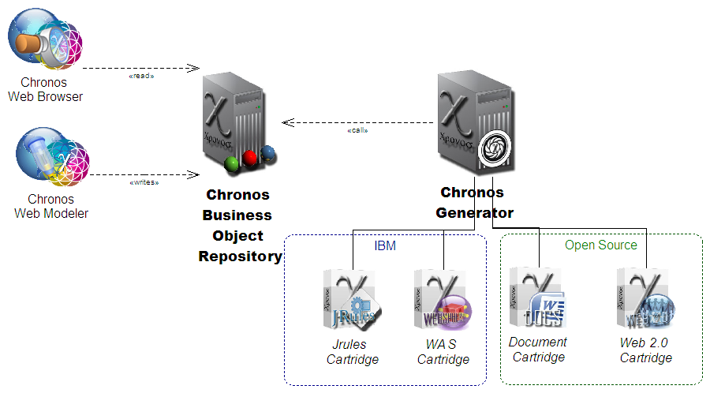Illustration 1: Chronos Business Object Repository in the context
The Chronos BusinessObject Repository is the backend application for Chronos Web Tools and other front end programs. It hosts a repository of Chronos Objects and offers the services to access to them.
The BOR is supposed to remain an invisible presence for end users, but is useful for administrators.

Starting the BOR

Start URL in a supported browser ( firefox minimum version 3 or google Chrome).

https://SERVERNAME /cwm/application
this is directory where is index.html file you also could have started main.php directly.

An overview about available functionality is then shown.

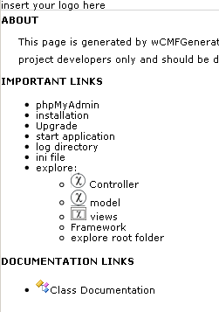

Click link [start application] to start the administration tool, you will get a login panel first.

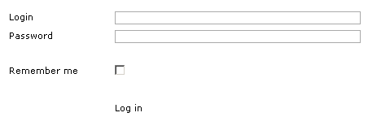

Fill in user name and password and click link [Log in].
if you don’t want to type in your login information next time you login, mark ‘Remember me’ selected before

You will see then something like following screenshot, in this case on model level.

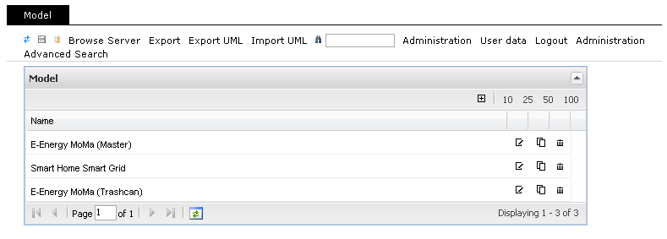

You entered now the administration tool.

Structure of the page
The application window is divided into two areas. At the top is the navigation, the lower part hosts the contents. The navigation consists on a series of tabs that links the elements of various content types . After clicking a tab at the bottom a list of the content type associated elements will be shown .
Double-clicking an item bring to the details view, in which the element can be edited.
If the element associated with other elements, they are displayed in the right pane as a list.
Below the tabs is a list of links for the following functions:
Update: The content of the page is reloaded. Changes in the forms are lost. The function is useful for unexpected changes, the unsaved, to undo
Store: The entered form data. This function should always be run after making changes. When leaving the mask the changes will be lost!
Tree: A new window will appear a tree view of the contents. Click on a node of the tree will open the corresponding content in the details view.
Media pool: A new window displays the media pool. This includes all images and other resources (eg downloadable files). See section 1.10.
Search: The simple search is executed. See Chapter 1.4.
Advanced search: In a new window appears the search for advanced search. See Chapter 1.4.
Administration: From the CMS-view is changed in the administration view. See section 1.12.
CMS: From the Administration view is changed in the CMS-view.
User Data: The window for changing the user password opens.
Unsubscribe: The current session ends and displays the login screen.

Functionalities of the Chronos Business Object Repository
With the BOR you are able to

- read and edit modelling objects and its hierarchical structure
- show content tree

- administer users and their roles
- create and edit configuration files
- change your own user data like password

- search modelling objects, users and roles

read and edit modelling objects and its hierarchical structure,
show content tree

Read, create and edit modelling objects and its hierarchical structure

You see at first a list of models, double-click on one model opens model properties and shows all connections on the right side of the screen.

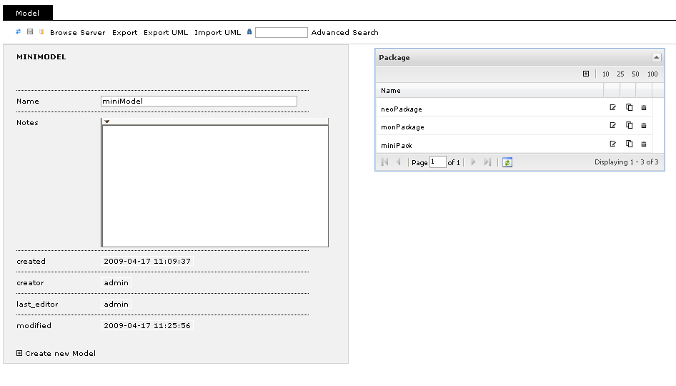
With the same procedure double-click on one connected object on the right you open this one on left side and its connected objects are now shown on the right.

Note, all connected objects are shown. This include the parent object “mini model”. In this way it is possible to easily navigate in tree all directions.

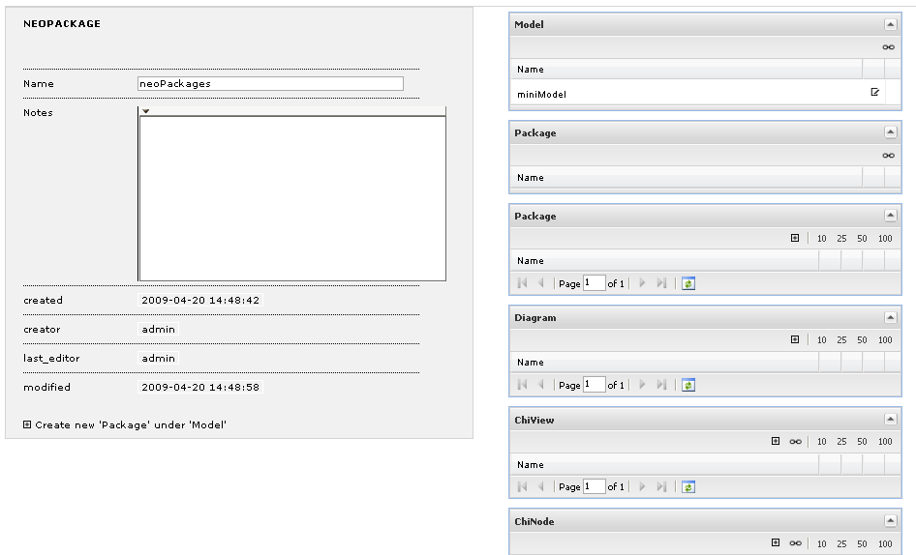

To create a new object you click the [+] Create new ‘Objectname’ link and then opens a new Panel where you can type in the necessary Values.
To save the changes click the save symbol on the top left corner.

As you can see there is one more Object created.
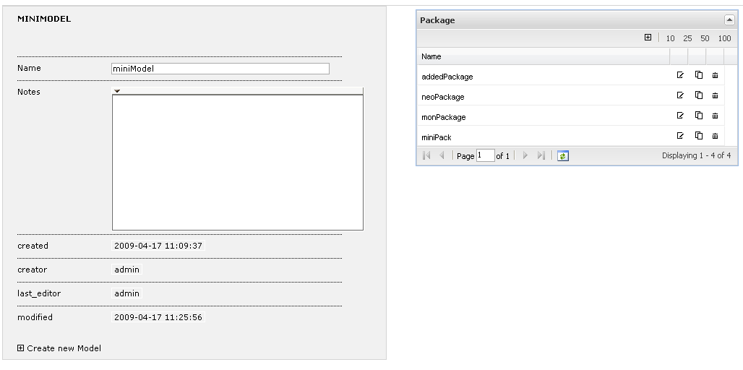

Editing of existing Objects is working in an analogue way.

Show content tree

Click link [Administration].

Anywhere in this area click link [Content Tree] from top left corner and there is opening a separate window to browse the hierarchy of modelling objects.

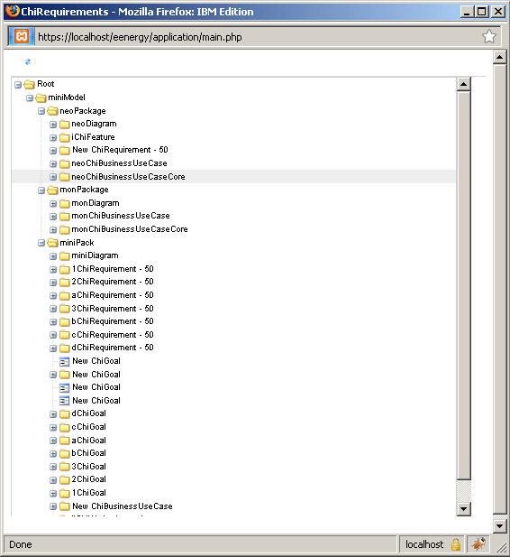

Click link [CMS] on the top right corner to go back to the model objects overview.

administer users and their roles, create and edit configuration files, change your own user data like password

How to arrange configuration files roles and users

You can get a detailed description on sourceforge wcmf documentation about configuration. See http://wcmf.sourceforge.net/docs/html/configuration.html#configuration .

You are able to create and change configuration files using administration tool instead of editing on file system. See ‘create a configuration file’ and ‘edit a configuration file’.

Example configuration files:

config.ini is the default and main configuration file. Here you save the mapping between roles and configuration files in section [roleconfig].
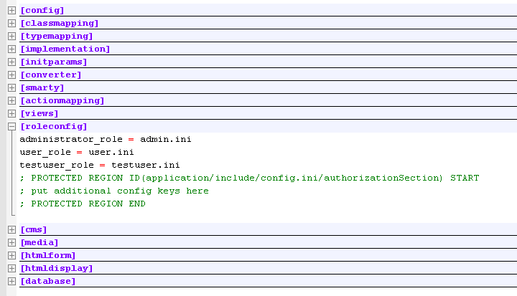
same in administration tool looks like this
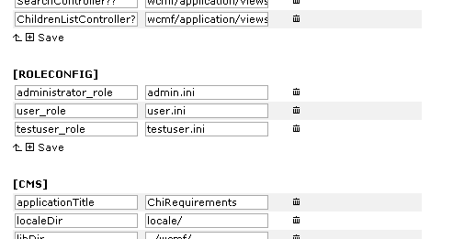

user.ini is the special configuration file for users which are able to do everything on application except displaying the historylist of all objects. In this ini is the only entry the exception of rights for the role and users in section [authorization].
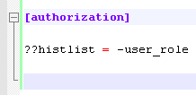
same in administration tool would be
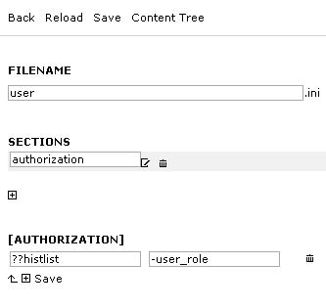

admin.ini is the special configuration file for administrators meens users who are able to do everything on application, so you don’t really need this ini or any entry in this case and would have the same behaviour. But to hold on definition and to show a consistent and readable configuration you could create it with following shown entry.
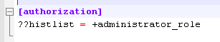
in administration tool looks like this
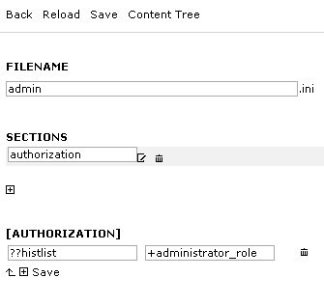

You are able to control all actions in section [actionmapping].

The structure is as following:
[OBJECTNAME]??[ACTIONNAME]=-[GROUPNAME]

for example
??exportUWM=-externals
means that the group “external” is not allowed (the minus sign) to perform the action exportUWM

ChiRequirement??delete=-readers
disallow the group readers from deleting ChiRequirements

??delete=-externals
The group “external” cannot delete objects at all.

get an overview about existing users and their roles

Click the link [Administration] on top right corner and you will see a list of users, roles and configuration files. The category Backup is also shown there.
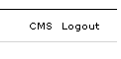
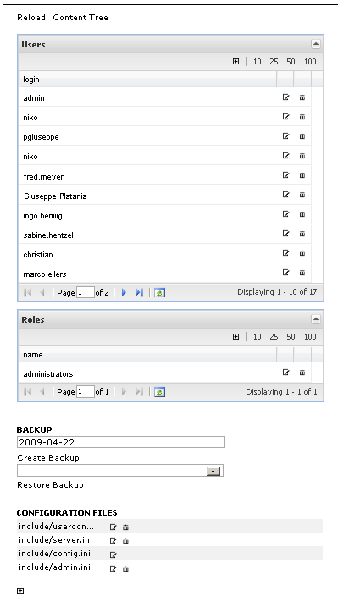

Click link [CMS] on the top right corner to go back to the model objects overview.

Change the properties of an existing user

To edit a user click beside the user name or doubleclick the name directly. Then there is opening a Panel showing all values corresponding to the user and to change all of these values.

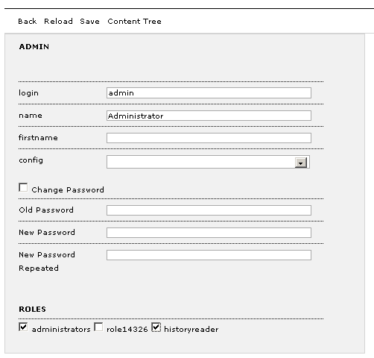

To change the password mark field ‘Change Password’ selected and type the old one (text in clear) in the ‘Old Password’ field and the new one in fields ‘New Password’ and ‘New Password Repeated’.

Click link [save] to confirm the change.

(Note, there is no way to change the password without typing in clear even as an administrator. To reset the password just delete the user and create a new one with a new password.)

Add a new user

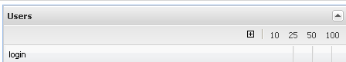

Click [+] to open a new user panel where you can type in the required values.

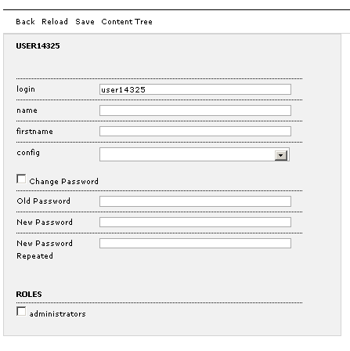
To create a password you have to select Change Password and leaf the Old Password field empty.

Click link [Save] to save the new user.

Delete a user

There is a trash symbol beside the username in the user names list. Click on it to delete the entry, you will receive a confirmation message to confirm deleting.

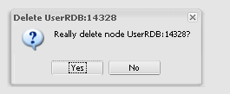

Change the properties of an existing role
To change the property of an existing role click on a role and edit the name or the users.
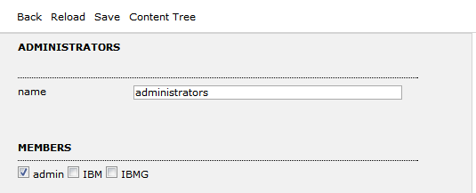

Add a new role

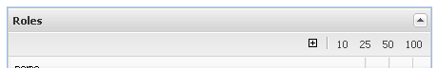

To add a new role click the symbol. Then you will see a new role panel where you can type in the name and check users who have this role applied. To save your changes click link [Save].

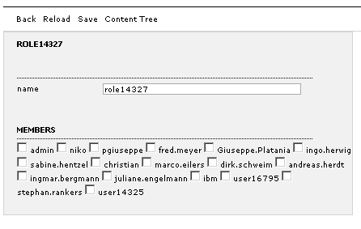

Delete a role

To delete a role click the trash symbol beside the role name in the role list.
You will get an confirmation message to confirm the deletion.

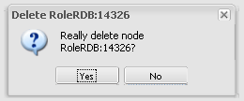

Create an configuration file
The BOR is configured via more configuration files .
See for details Appendix 1: Configuration and the topic ‘get an overview about existing users’, where the configuration files are listed.

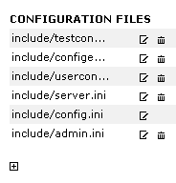
To crate a new configuration file click on the [+] symbol on the bottom.

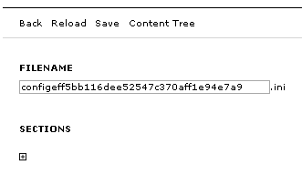
Create a section clicking on symbol [+] and type in the filename and the sections name.

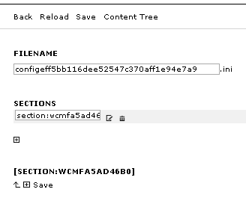

Click link [Save] to save changes. You will see the non editable sections name on the bottom also changes.

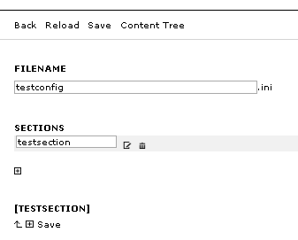

Now you are able to create an option in section by clicking [+].

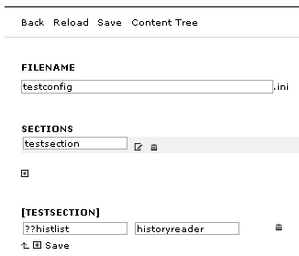

This entry will be written to the config file in the format ??histlist = historyreader. Confirm your change by clicking link [Save].

Delete a configuration file

See topic ‘get an overview about existing users’, there are listed the configuration files too.

To delete one of these entries click on the trash symbol beside the entry.

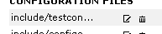

Your will get a confirmation message to confirm the deletion.

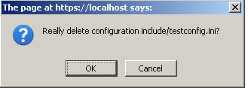

You can not delete the default configuration file because just one default file is needed every time.

Edit a configuration file

See topic ‘get an overview about existing users’, there are listed the configuration files too. To edit a configuration file click on its name or on the edit symbol .

Then you will see all given properties of configuration file.

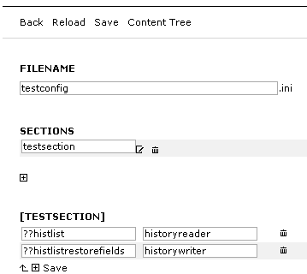

Edit your own user data like password

Click [User data] on the top right corner to open the password change panel. Type in the old and new password in the fields and click link [Save] to confirm.

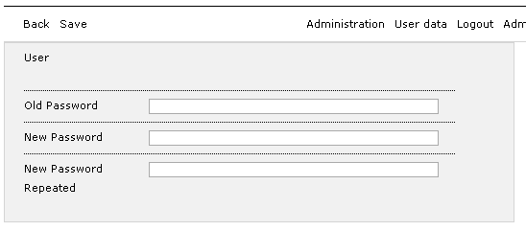

search modelling objects, users and roles

Simple search:

On the top you see some action links and among these a field to start searching. Type in the search key, for instance ‘user’, you are looking for and click the spyglass symbol to start action.

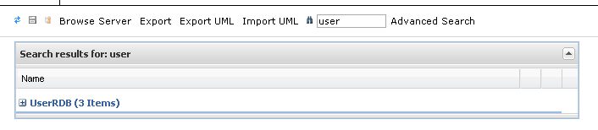

Expanding section by clicking [+] symbol all the result entries are shown.

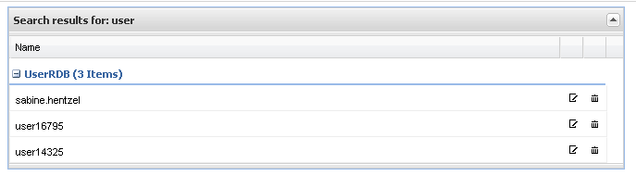

Advanced search

To perform an advanced Search just click action [Advanced Search] to open the separate advanced search window.

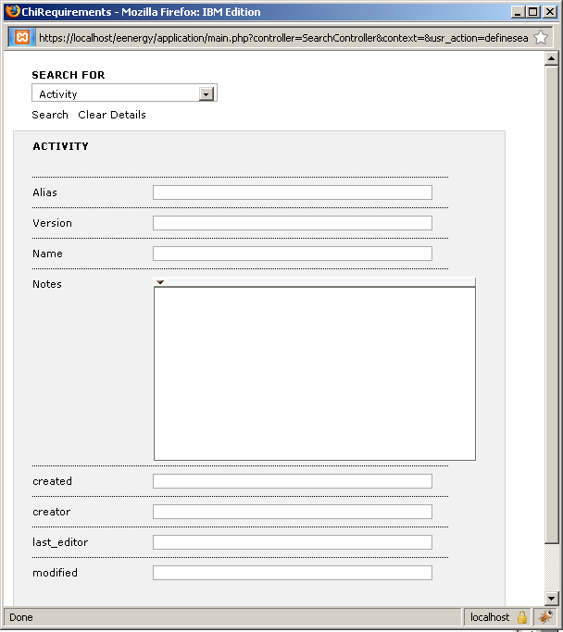

Select one type from the list to get the right search panel depending on special type.

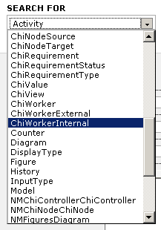
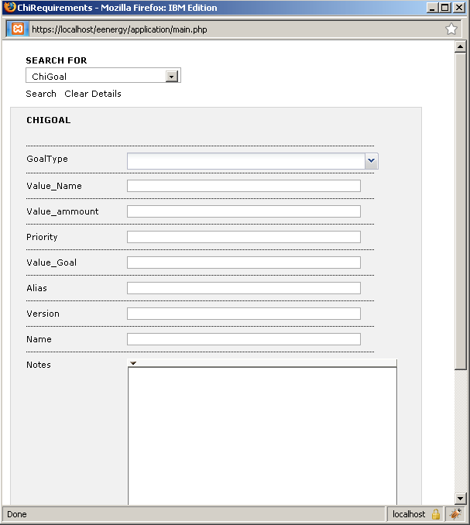
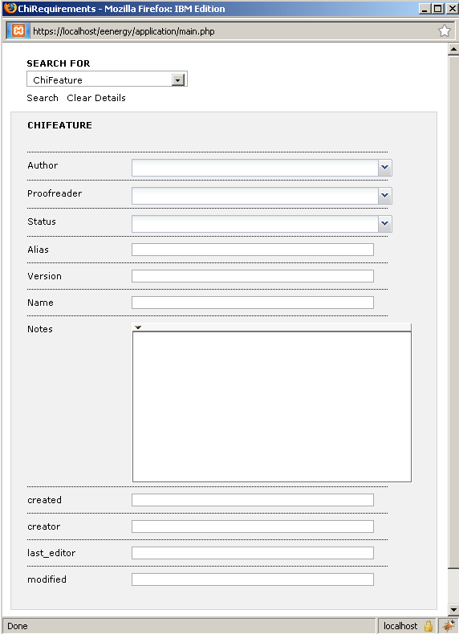

Type in search keys related to each field shown to specify the search. Click link [Search] to start searching on the given criteria.

Results are shown in underlying window like simple search.
Still Open Points

(in Administration area overviewing user, roles and configuration files)
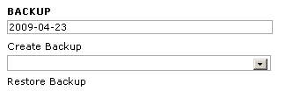

- link [Create Backup]
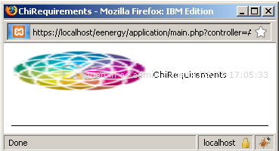
(no message any more and no file found)
.. later on: a second administration window opens

- link [Restore Backup] (no selection possible)

(in normal user area)

- link [Export]
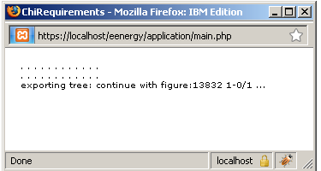
(no message any more but
the export XML file was successfully created in relative path application)

- link [ExportUML] (currently not available)

- link [ImportUML] (currently not available)

  - link [Browse Server] (File Upload not working)

Appendix 1: Configuration
The application is configured via one (or more) configuration file(s), which are parsed by the WCMFInifileParser class. The configuration parameters are defined by key-value pairs as they are used in the ini file format. The application interprets values, which are enclosed in curly brackets ({}), as arrays. Related parameters are arranged in sections.
Note:
Please note, that the framework interprets paths - if not explicitly indicated otherwise - as relative to the BASE path, which is defined in /application/base_dir.php. This is the root directory of /wcmf and /application by default.
- Action Keys
- Configuration for individual users
- Configuration file sections
- Example of a configuration file

Action Keys
An important concept of the application's configuration is that of Action Keys. An action key describes the state of the application together with the action to be performed next. The state, which the application is in, results from the current controller and the context, in which it is executed. Controllers must exist as classes, whereas contexts and actions can be defined freely. They must only be taken care of in the controllers and if necessary transported between the views (as form data, see also Programming the application, Programming the views).
The format of the action keys is the following:
controller?context?action
In the configuration file an action key has the controller assigned, which should be executed next if the action key is valid by the application's current state and the user action or the return value of the current controller (see also Application flow).
Since parts of the action key can be omitted in the definition, an algorithm has to choose, which action key fits a given value triplet. This algorithm is implemented in the method WCMFInifileParser::getBestActionKey. In this method the InifileParser searches in the configuration file for the a list of combinations successively and ends the search when it found one. After that the controller, which is assigned to that combination, is executed. The order of the combinations is the following:
1. controller?context?action
2. controller??action
3. controller?context?
4. ?context?action
5. ??action
6. controller??
7. ?context?
As a rule of thumb the action key which describes the state of the application the most accurate is favoured.
Frequent examples are:
Always execute the SaveController when action save is selected, no matter which state the application is in:
??save = SaveController
Always execute the ProjektController when the context is project as long as no action is specified, return to the ProjektController respectively from all controllers, which have no specific action assigned upon termination:
?project? = ProjectController
If no matching action key can be found, the ActionMapper tries to execute the last Controller that had a view attached again. This can save some typing. For example you don't need to configure an action key for the ok return action of SaveController, if you always want to execute the Controller afterwards, from which the save action was initiated.

Configuration for individual users
In the table user of the database scheme (see also Database scheme) each user can have her own configuration file assigned. This will be loaded after the standard configuration (config.ini) and extends its settings. If two keys have the same name the one from the user configuration overwrites the standard one. Using the roleconfig configuration section, you can easily asign configuration files to groups (see below).

Configuration file sections
The following sections are known to the framework classes. Whatever parameter is necessary for the application can be defined in further sections and can be read using the methods of the WCMFIniFileParser.

[config]
This section refers to the configuration files. The following keys are known to the framework::
include = array with configuration files
; allows the inclusion of further configuration files
; (Included values don't overwrite the current)
; used in: class.InifileParser.php
hiddenSections = array with sections
; allows the hiding of sections in the admintool
; used in: class.InifileParser.php
readonlySections = array with sections
; allows the protection of sections in the admintool
; used in: class.InifileParser.php

[classmapping]
Since Controller, PersistenceMapper and other classes in the configuration file's sections are only labeled with their classnames, the framework needs information, in which files the class definitions can be found. In the section classmapping therefore a corresponding definition file for each class is given.
classname = path_to/classfilename

[typemapping]
The relation between domain classes and their PersistenceMappers (see Data storage) is set in the section typemapping. A * as key means that all types, which are not specified, will be handled by the assigned PersistenceMapper. The PersistenceFacade uses these information to find the appropriate PersistenceMapper classes for the domain classes.
type = mapperClass

[implementation]
In some cases the framework offers different implementations for abstract classes. At the moment this refers to basic services, which access the data storage (database, XML), e.g. AuthUser. The implementation, which should be used by the framework can be specified in this section. For the following classes an implementation can be chosen:
LockManager = LockManagerRDB|BusyLockManager|NullLockManager
UserManager = UserManagerRDB|UserManagerXML
User = UserRDB|UserXML
Role = RoleRDB|RoleXML
UserRole = NMUserRole
View = View|NullView
ControlRenderer = DefaultControlRenderer
ValueRenderer = DefaultValueRenderer
HTMLFormat = HTMLFormat
JSONFormat = JSONFormat
SOAPFormat = SOAPFormat
Furthermore this mechanism allows developers to provide own implementations of the abstract classes.

[initparams]
Since some classes require specific parameters in their constructors (e.g. database connection), these parameters can be grouped in sections (e.g. [database]) and referenced in the section initparams. The keys are the classnames and the values the corresponding parameter sections. The key-value pairs of the parameter section will be passed as associative array to the constructor upon creation of the objects.
class = initsection

[converter]
In this section DataConverters for types are configured (see Data storage):
type = converterClass

[actionmapping]
In the section actionmapping the actual application flow is defined. This is achieved by defining the transition from one controller to the next.
The key is an action key (see Action Keys), which clearly describes the state the application is in before the transition. The value sets the next controller to execute. The ActionMapper uses this information to determine which Controller is executed next.
controllerA?context?action = controllerB

[views]
For each controller a view can be defined dependent on its context and action, which is described by its Smarty template (.tpl file). In the section views each action key can have a view template assigned (see Action Keys). The controller uses this information to determine its view.
controllerA?context?action = view

[authorization]
The Authorization is based on action keys (see Action Keys), whereby the following actions can be defined by the individual parts of the key:
controller?context?action ; an action in the application flow
type?context?action ; an action on a domain class (read, modify, delete, create)
oid?context?action ; an action on a domain object (read, modify, delete, create)
To each of these actions different roles can be assigned (comma separated), for which a permission is granted (+) or denied (-). The role * stands for all roles.
If a permission is not explicitly granted, it is considered as denied. For not listed Aktion Keys the decision is made by the _defaultPolicy of the AuthUser. The RightsManager uses this information to authorize an AuthUser for an action.
The following code shows an example, where the creation of Category instances is only allowed for users having the administrators role:
Category??create = -authors +administrators

[roleconfig]
Allows auto assignment of an additional configuration file for different user roles. If a user is added to a listed role, then the given configuration file will be automatically assigned by the UserManager (see also Configuration for individual users).
rolename = configurationfile
For example if users of the administrators role should always use the admin.ini configuration file you could add the following entry:
administrators = admin.ini

[cms]
This section refers to the general application configuration. The following keys are known to the framework::
applicationTitle = application title
; specifies the title which appears in the default application
; used in: class.Controller.php, locale.php
rootTypes = array of domain classes
; declaration of types, which don't have parent types to allow them to be created
; on the top level of the default application
; used in: class.DisplayController.php, class.TreeViewController.php,
; class.XMLExportController.php, graph.php
anonymous = 0|1
; indicates, if the user must authenticate himself upon application start.
; If the value is 1 the rights management is also disabled.
; used in: class.LoginController.php, class.RightsManager.php
exportDir = path (relative to main.php !)
; sets the root directory for the export of static pages
; used in: class.PageExportController.php
htmlBaseDir = path (relative to main.php !)
; sets the root directory for the html output
; used in: class.LinkConverter.php
backupDir = path (relative to main.php !)
; sets the root directory for backups
; used in: class.BackupController.php
libDir = path (relative to main.php !)
; sets the root directory of the framework
; used in: class.TreeViewController.php, resource.lib.php, class.FormUtil.php
localeDir = path (relative to main.php !)
; sets the language directory of the application
; used in: main.php, class.I18nUtil.php, po2array.php
logDBActions = 0|1
; specifies, whether database access should be logged in the logfile
; used in: main.php
logSQL = 0|1
; specifies, whether the logging of the database layer is activated
; ADOdb then logs all access in the table adodb_logsql
; used in: class.NodeRDBMapper.php, class.NodeToSingleTableMapper.php,
; class.LockManagerRDB.php, class.AuthUserRDB.php, class.UserManagerRDB.php
logExecuteTime = 0|1
; specifies, whether to log the time each controller needs to execute
; used in: class.ActionMapper.php
debugView = 0|1
; specifies, whether Smarty should create debug output in a popup window
; used in: class.Controller.php
language = language code (e.g. en_EN)
; specifies the application's language (see Message::get)
; used in: main.php, locale.php
usegettext = 0|1
; specifies, whether the function gettext should be used for the localization of the
; application (see Message::get).
; used in: class.Message.php
locking = 0|1
; specifies, whether data is locked when it's opened by another user
; used in: class.LockManager.php

[htmlform]
The definition of the input controls, that are used in the application, is done in Smarty templates (see DefaultControlRenderer). In this section the templates are assigned to control names.
The following input controls are already defined by the framework:
- text
- textarea
- password
- select
- radio
- checkbox
- file
- fileex
- filebrowser
- linkbrowser
- fckeditor
- date
Furthermore the following keys are known to the framework:
maxFileSize = number
; specifies the maximum size of files to upload (in bytes)
; used in: class.FormUtil.php, class.NodeUtil.php,
class.SaveController.php, class.FileUtil.php
inputFieldNameDelimiter = char
; specifies the separator, which is used for creation of inputfield names
; (e.g. separator "-": "value-1-name-Author:0")
; used in: class.SaveController.php, class.NodeUtil.php,
class.FormUtil.php

[htmldisplay]
The definition of the value display types, that are used in the application, is done in Smarty templates (see DefaultValueRenderer). In this section the templates are assigned to value type names.
The following value types are already defined by the framework:
text
image

[smarty]
The smarty section contains configuration parameters for the Smarty Template Engine.
compileCheck = 0|1
; specifies, whether Smarty should test for modifications
; in the templates upon each call
; used in: class.Controller.php
templateDir = path (relative to main.php !)
; specifies the smarty directory (the paths /smarty/templates_c
; and in case of caching=1 /smarty/cache must exist in that directory)
; used in: class.Controller.php
caching = 0|1
; specifies, whether Smarty should use caching
; in case of a cms application caching is a good alternative to exporting
; static pages
; used in: class.Controller.php
cacheLifetime = -1|number of seconds
; specifies, the lifetime of the Smarty cache in seconds
; the value is ignored if caching is not enabled
; used in: class.Controller.php

[media]
In this section settings for the upload of media files are specified.
imgWidth = array of a number and 0|1
; sets - if specified - the width of an upload image
; the second parameter specifies if the value must be matched exactly (1)
; or if it is a maximum (0)
; e.g. {625, 0}
; used in: class.SaveController.php
imgHeight = array of a number and 0|1
; sets - if specified - the height of an upload image
; the second parameter specifies if the value must be matched exactly (1)
; or if it is a maximum (0)
; e.g. {625, 1}
; used in: class.SaveController.php
uploadDir = path (relative to main.php !)
; specifies the directory, into which the SaveController uploads media files
; used in: class.SaveController.php, class.FormUtil.php

Example of a configuration file

[config]

[classmapping]
BackupController = wcmf/application/controller/admintool/class.BackupController.php
AdminController = wcmf/application/controller/admintool/class.AdminController.php
ConfigController = wcmf/application/controller/admintool/class.ConfigController.php
PrincipalController = wcmf/application/controller/admintool/class.PrincipalController.php
EditRightsController = wcmf/application/controller/admintool/class.EditRightsController.php
MySQLBackupController = wcmf/application/controller/admintool/class.MySQLBackupController.php
BatchController = wcmf/application/controller/class.BatchController.php
LongTaskController = wcmf/application/controller/class.LongTaskController.php
DeleteController = wcmf/application/controller/class.DeleteController.php
DisplayController = wcmf/application/controller/class.DisplayController.php
FailureController = wcmf/application/controller/class.FailureController.php
InsertController = wcmf/application/controller/class.InsertController.php
LoginController = wcmf/application/controller/class.LoginController.php
PageExportController = wcmf/application/controller/class.PageExportController.php
SimplePagingController = wcmf/application/controller/class.SimplePagingController.php
SortController = wcmf/application/controller/class.SortController.php
AssociateController = wcmf/application/controller/class.AssociateController.php
ResourceTreeController = wcmf/application/controller/class.ResourceTreeController.php
PagingController = wcmf/application/controller/class.PagingController.php
SaveController = wcmf/application/controller/class.SaveController.php
SimpleBatchController = wcmf/application/controller/class.SimpleBatchController.php
SimpleLongTaskController = wcmf/application/controller/class.SimpleLongTaskController.php
TreeViewController = wcmf/application/controller/class.TreeViewController.php
ViewController = wcmf/application/controller/class.ViewController.php
XMLExportController = wcmf/application/controller/class.XMLExportController.php
CopyController = wcmf/application/controller/class.CopyController.php
UserController = wcmf/application/controller/class.UserController.php
ResourceListController = wcmf/application/controller/class.ResourceListController.php
SearchController = wcmf/application/controller/class.SearchController.php
SOAPController = wcmf/application/controller/class.SOAPController.php
ChildrenListController = wcmf/application/controller/class.ChildrenListController.php
NodeListController = wcmf/application/controller/class.NodeListController.php
Controller = wcmf/lib/presentation/class.Controller.php
UserRDB = application_1/include/model/wcmf/class.UserRDB.php
UserRDBRDBMapper = application_1/include/model/wcmf/class.UserRDBRDBMapper.php
RoleRDB = application_1/include/model/wcmf/class.RoleRDB.php
RoleRDBRDBMapper = application_1/include/model/wcmf/class.RoleRDBRDBMapper.php
NMUserRole = application_1/include/model/wcmf/class.NMUserRole.php
NMUserRoleRDBMapper = application_1/include/model/wcmf/class.NMUserRoleRDBMapper.php
Locktable = application_1/include/model/wcmf/class.Locktable.php
LocktableRDBMapper = application_1/include/model/wcmf/class.LocktableRDBMapper.php
Adodbseq = application_1/include/model/wcmf/class.Adodbseq.php
AdodbseqRDBMapper = application_1/include/model/wcmf/class.AdodbseqRDBMapper.php
LockManagerRDB = wcmf/lib/persistence/class.LockManagerRDB.php
UserManagerRDB = wcmf/lib/security/class.UserManagerRDB.php
View = wcmf/lib/presentation/class.View.php
DefaultControlRenderer = wcmf/lib/presentation/class.DefaultControlRenderer.php
DefaultValueRenderer = wcmf/lib/presentation/class.DefaultValueRenderer.php
HTMLFormat = wcmf/lib/presentation/format/class.HTMLFormat.php
JSONFormat = wcmf/lib/presentation/format/class.JSONFormat.php
SOAPFormat = wcmf/lib/presentation/format/class.SOAPFormat.php

[typemapping]
UserRDB = UserRDBRDBMapper
RoleRDB = RoleRDBRDBMapper
NMUserRole = NMUserRoleRDBMapper
Locktable = LocktableRDBMapper
Adodbseq = AdodbseqRDBMapper

[implementation]
LockManager = LockManagerRDB
UserManager = UserManagerRDB
User = UserRDB
Role = RoleRDB
UserRole = NMUserRole
View = View
ControlRenderer = DefaultControlRenderer
ValueRenderer = DefaultValueRenderer
HTMLFormat = HTMLFormat
JSONFormat = JSONFormat
SOAPFormat = SOAPFormat

[initparams]
UserRDBRDBMapper = database
RoleRDBRDBMapper = database
NMUserRoleRDBMapper = database
LocktableRDBMapper = database
AdodbseqRDBMapper = database

[converter]

[actionmapping]
??fatal = FailureController
??delete = DeleteController
DisplayController?? = DisplayController
DisplayController??treeview = TreeViewController
DisplayController??failure = FailureController
DisplayController??definesearch = SearchController
DisplayController??list = NodeListController
DisplayController??edituser = UserController
DisplayController??search = SearchController
DisplayController??listchildren = ChildrenListController
LoginController??ok = DisplayController
UserController??ok = DisplayController
??cms = DisplayController
??display = DisplayController
??new = InsertController
LoginController??failure = LoginController
LoginController??dologin = LoginController
??login = LoginController
??logout = LoginController
SimplePagingController?? = SimplePagingController
??sortup = SortController
??sortdown = SortController
??disassociate = AssociateController
??associate = AssociateController
ResourceTreeController?? = ResourceTreeController
??browseresourcetree = ResourceTreeController
??save = SaveController
TreeViewController?? = TreeViewController
??copy = CopyController
UserController??save = UserController
UserController?? = UserController
ResourceListController?? = ResourceListController
ResourceListController??delete = ResourceListController
??browseresources = ResourceListController
SearchController?? = SearchController
??soapList = SOAPController
??soapCreate = SOAPController
??soapUpdate = SOAPController
??soapRead = SOAPController
??soapDelete = SOAPController
ChildrenListController?? = ChildrenListController
NodeListController?? = NodeListController

[views]
DisplayController?? = wcmf/application/views/displaynode.tpl
FailureController?? = wcmf/application/views/displayfailure.tpl
LoginController?? = wcmf/application/views/login.tpl
ResourceTreeController?? = wcmf/application/views/resourcetree.tpl
TreeViewController?? = wcmf/application/views/treeview.tpl
UserController?? = wcmf/application/views/user.tpl
ResourceListController?? = wcmf/application/views/resourcelist.tpl
SearchController??definesearch = wcmf/application/views/searchpanel.tpl
SearchController?? = wcmf/application/views/searchresult.tpl
ChildrenListController?? = wcmf/application/views/childrenlist.tpl
NodeListController?? = wcmf/application/views/nodelist.tpl

[authorization]

[roleconfig]
administrators = admin.ini

[database]
dbType = mysql
dbHostName = localhost
dbName = wcmf
dbUserName = wcmf
dbPassword = geheim

[smarty]
templateDir = include/views/
compileCheck = 1

[cms]
applicationTitle = DEFAULT
localeDir = locale/
libDir = ../wcmf/
exportDir = ../../html/
htmlBaseDir = ../../html/
backupDir = backup/
language = en_EN
usegettext = 0
debugView = 0
logDBActions = 0
logSQL = 0
logExecuteTime = 0
anonymous = 0
locking = 1
rootTypes = {}

[media]
uploadDir = ../../html/images/

[htmlform]
inputFieldNameDelimiter = -
maxFileSize = 200000
text = wcmf/application/views/forms/text.tpl
textarea = wcmf/application/views/forms/textarea.tpl
password = wcmf/application/views/forms/password.tpl
select = wcmf/application/views/forms/select.tpl
radio = wcmf/application/views/forms/radio.tpl
checkbox = wcmf/application/views/forms/checkbox.tpl
file = wcmf/application/views/forms/file.tpl
fileex = wcmf/application/views/forms/fileex.tpl
filebrowser = wcmf/application/views/forms/filebrowser.tpl
linkbrowser = wcmf/application/views/forms/linkbrowser.tpl
fckeditor = wcmf/application/views/forms/fckeditor.tpl

[htmldisplay]
text = wcmf/application/views/display/text.tpl
image = wcmf/application/views/display/image.tpl

